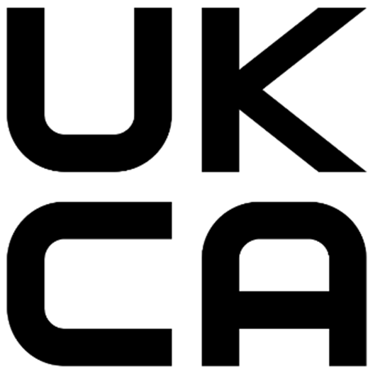
UKCA Marking Updated Guidance
There has been extensive engagement with industry to understand the challenges businesses face as they adopt the new UK regulatory regime for goods. The UK Government wants to be pragmatic and support businesses where possible.
Therefore, further measures have been introduced to support businesses adopting the UKCA marking.
EXCEPTIONS: These changes do not apply to medical devices, construction products, cableways, unmanned aircraft systems, transportable pressure equipment, rail products and marine equipment. Departments responsible for these sectors are making sector specific arrangements.
The four new policy measures are outlined below:
RETESTING
We will reduce re-testing costs for UKCA certification, by allowing conformity assessment activities for CE marking completed by the 31 December 2022 to be used by manufactures as the basis for UKCA marking. This will reduce the immediate costs faced by manufacturers and will be valid until the expiry of their certificate or for 5 years (31 December 2027), whichever is sooner. This will reduce duplication and costs for businesses and by extension, consumers.
EXISTING STOCK
We will make clear there is no need to re-test existing imported stock, as these products will be considered already placed on the market In Great Britain (GB). This will prevent the costly, and unnecessary re-labelling of existing stock for businesses.
SPARE PARTS
We will make clear that spare parts that repair, replace or maintain goods already on the GB market can meet the same requirements that were in place at the time the original product or system was placed on the GB market. This will allow products and goods requiring spare parts to continue to be maintained.
LABELLING
We will continue to allow businesses to affix the UKCA marking, and to include importer information for products from EEA countries (and in some cases Switzerland), on an accompanying document or label until 31 December 2025. This will allow business to adjust their product design to accommodate marking changes at a convenient and cost-effective time.
Further information on https://www.gov.uk/guidance/using-the-ukca-marking

